

**POLICY – BORDER RESIDENTS**

**Friday, 18 September 2020**

The following policy has been implemented by Racing NSW to permit persons who reside in the Border Region of the NSW and Victorian border (as defined by the NSW Public Health Order) more flexibility in terms of movement between states.

Effective immediately:

**Licensed Persons, Officials, Race Club Employees & Service Providers**

1. Victorian residents who currently reside in the border region (see attached map) can attend NSW licensed premises and racecourses, but only within the border region, upon provision of a signed declaration that they have not travelled to an area of Victoria outside the border region or an area that is a COVID-19 concern within the previous 21 days;
2. NSW residents who currently reside in the border region can travel within the border region (including Victoria) and may also travel outside the border area within NSW and attend any NSW licensed premises or racecourse, upon provision of a signed declaration that they have not travelled to an area of Victoria outside the border region or an area that is a COVID-19 concern within the previous 21 days.
3. Any person who resides in the border region (either a NSW or Victorian resident) and has been in an area of Victoria outside the border region or an area that is a COVID-19 concern within the previous 21 days, must not enter a NSW licensed premises or racecourse.

The declaration below must be completed, signed and sent to [steward@racingnsw.com.au](mailto:steward@racingnsw.com.au) prior to travelling and must receive approval from Racing NSW Stewards prior to travelling.

**Persons Attending Race Meetings other than Licensed Persons, Officials, Race Club Employees & Service Providers**

1. Victorian residents who currently reside in the border region (see attached map) can attend a NSW race meeting, but only within the border region, and subject to declaring upon entry that they have not travelled to an area of Victoria outside the border region or an area that is a COVID-19 concern within the previous 21 days;
2. NSW residents who currently reside in the border region can attend a NSW race meeting subject to declaring that they have not travelled to an area of Victoria outside the border region or an area that is a COVID-19 concern within the previous 21 days.
3. Any person who resides in the border region (either a NSW or Victorian resident) and has been in an area of Victoria outside the border region or an area that is a COVID-19 concern within the previous 21 days, must not enter a NSW licensed premises or racecourse.

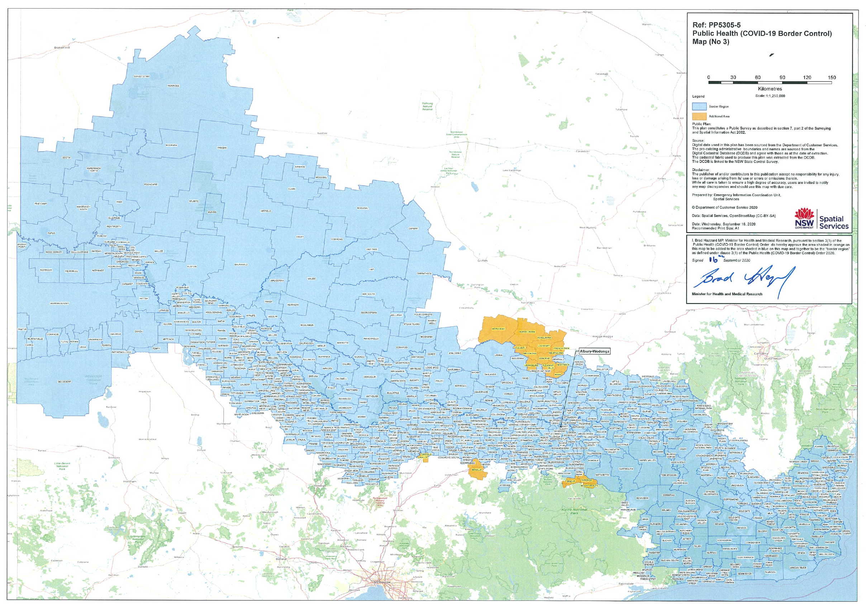



**COVID DECLARATION – BORDER RESIDENT**

**I** Click or tap here to enter text. **(Name) declare that I am a resident of** Click or tap here to enter text. **(NSW or Victoria) and currently reside within the declared Border Region as defined by the NSW Public Health (COVID-19 Border Control) Order. I declare that I have not been to any area of Victoria outside the Border Region or an area that is a COVID-19 concern within the previous 21 days. Further, I declare that if I do attend any area of Victoria outside the Border Region or an area that is a COVID-19 concern I will immediately report such occurrence to Racing NSW and will not attend a NSW Licensed Premises or racecourse.**

**SIGNED _________________________ Date:** Click or tap to enter a date.

**NAME:** Click or tap here to enter text. **Contact No:** Click or tap here to enter text.

Declarations to be sent to [steward@racingnsw.com.au](mailto:steward@racingnsw.com.au).

Travel not permitted until approved in writing is received by the Stewards.